**Anomaly** **Detection in Credit Card Transactions**

Power BI Desktop

631K

6.42M

383

10.00M

0.06

3.58M

**isFraud** 0 1

40,000M

Sum of amount

20,000M

0M

nameDest Count Of Fraud Transactions

V

C185805228 2

C200064275 2

C410033330 2

C1002031672 1

C1007251739 1

C1009459055 1

C1009564356 1

C1009901500 1

C101179743 1

**Total** **383**

10M

5M

amount

8bn

6bn

Sum of amount

4bn

2bn

0.3bn

7.1bn

7.3bn

5.5bn

0.0bn

**161.5K (15.48%)**

**881.59K (84.52%)**

Avg Frau… Avg Nor…

nameDest Highest Number Of Transaction

V

C985934102 95

C1286084959 89

C248609774 87

C2083562754 85

C665576141 85

C1590550415 83

C977993101 80

C1360767589 79

C451111351 76

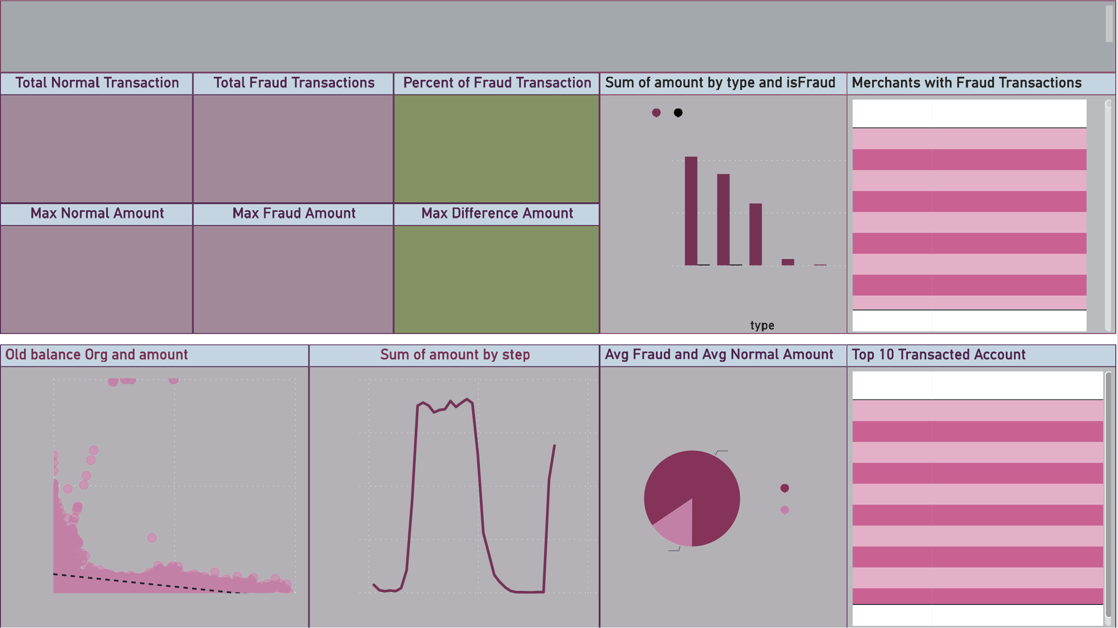0M

0M 20M 40M

oldbalanceOrg

0bn

0.0bn

0

20 40

step

C306206744 75

**Total** **834**

Analysis

Power BI Desktop

The transactions done by credit cards are analyzed and further discovered ,there are numerous fraudulent in the transactions.

* The total recorded transactions are 6,30,894 with 383 fraud transaction i.e 0.06% of the total transactions.
* The fraud transaction comprises 197 cash_out transactions and 186 transfer type, which means these two types require more attention towards transactional safety.
* The max amount of fraud done was of 10M with 6 individuals each which is a very big number in itself.
* There are 3 different customers who have been targeted twice for the fraud with the max amount of 828,720 at once.
* The total Fraud amount is approximately 102 billions.
* The most used is cash_out type with 224013transaction and approximately amount of 41 billions.
* The least used is debit type with only 4769 transactions and approximately amount of 29 millions.
* Steps between 15-20 consist of max amount of tranactions with approximately 7.3 billions.